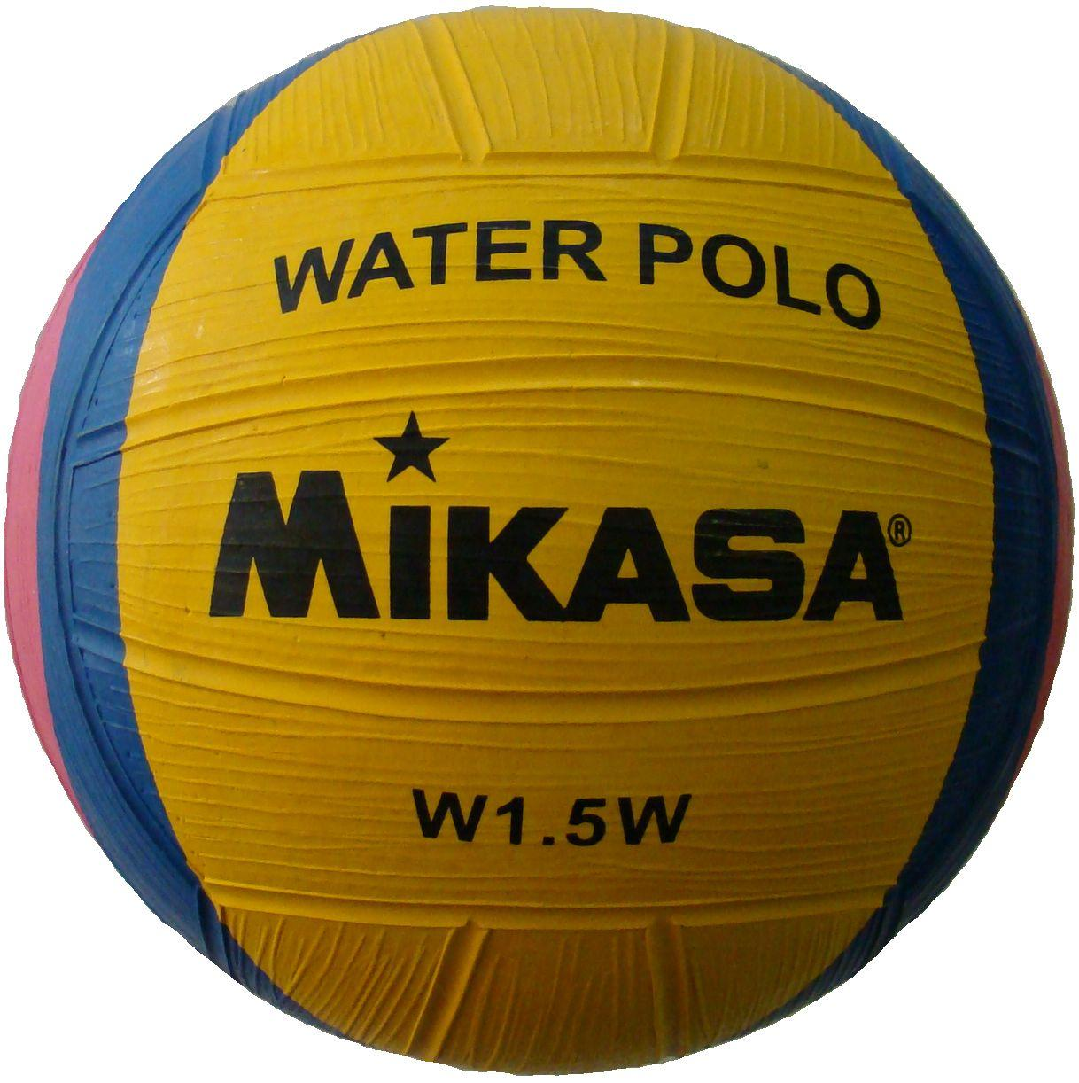
www.OPRFHSwaterpolo.org
Boys Water Polo 2016 – Tryout Criteria and Information

Required Paperwork: You MUST have a physical and athletic participation forms turned into the athletic office prior to Friday, February 26th, 4:00 to be on the try-out roster. NO EXECPTIONS!
- Your physical must be dated after June 1st, 2015 to be valid. Check early with the nurse or athletic office if you are unsure. Forms are available outside the athletic office or on the team website. You will not be able to try-out with out a valid physical!
- Athletic participation forms must be filled out for each season. Even if you were on another team this year, you need to fill out a new form. Forms are available outside of the athletic office or on the team website.
- You must have passed a minimum of five academic courses during first semester.

Open Gym: Dates: Feb. 8, 10, 17, 22, 24 (Monday’s and Wednesday’s, 3:30-5:00, West pool)

Tryouts*: Monday-Wednesday, Feb. 29-March 2, 4:30-6:30 pm in the West Pool. You must attend all tryout dates to be eligible for the team. All levels of players are welcome to tryout.
- Be ready to swim at 4:15. Players must bring their own swimsuit (speedo preferred), goggles and towel to each open gym and tryout.

Basic Water Polo Qualifications to try out:
- Egg-beater skill/ability to tread water for five minutes without the use of hand sculling
- Swim time, 500 yards without stopping
Player Selection:
- Swimming ability
- Passing/shooting/ball skills
- Evaluation of practice attitude, work ethic and varsity potential, grades
- Knowledge of the game/basic offense and defensive techniques
- Strength of legs/egg beater

Mandatory Parent Meeting for all players who make the team during the week of tryouts (after teams are made) at a location and time to be announced on the team website.

Water Polo Team Levels:
- Varsity: Approximately 15-17 players. Players selected based on their ability to contribute immediately to a state-caliber program.
- Junior Varsity: Approximately 15-20 players. The Junior Varsity is a developmental team designed to prepare players for varsity competition. Player selection will be based on the players potential to eventually contribute at the varsity level.

Additional Information: A $55 athletic participation fee must be made after teams are announced.

Practice Schedule: Due to limited pool time, teams will practice before and after school. A complete practice schedule will be available on the team website. Players are expected to be on time and at all practices unless a pre-arranged, excused absence has been cleared with the coaches. Any athlete with multiple excused absences may be excused from the team. Attendance will affect playing time.

Questions? Contact head varsity coach John Rapp, at jrapp85@gmail.com, or JV coach Bill Grosser at bgrosser@oprfhs.org (Room 129 before school).

